

**SCHOOL OF BUSINESS**

**STATE UNIVERSITY OF ZANZIBAR (SUZA)**

REG:NO BITA/5/21/049/TZ

LECTURE NAME MR. MASOUD HAMAD

# Designing Document: Boda Boda Management System

## 1. Introduction

### a. Why this Project/Problem Statement

The Boda Boda Management System aims to streamline and automate the operations of a Boda Boda (motorcycle taxi) business. The current manual system faces challenges in terms of inefficiency, lack of centralized data management, and limited accessibility. This project aims to address these issues and provide an efficient solution.

### b. Objectives

#### i. General objectives

* Develop a Boda Boda Management System with CRUD functionality.
* Improve operational efficiency and productivity.
* Centralize data management for better decision-making.

#### ii. Challenges of the current existing system

* Manual record-keeping and data entry.
* Inefficient scheduling and dispatching of rides.
* Lack of real-time tracking and monitoring.
* Limited accessibility and communication channels.

#### iii. Solution to current business operations

* Automate the process of ride scheduling, dispatching, and tracking.
* Enable efficient record-keeping and data management.
* Improve accessibility through mobile and web interfaces.

### c. Deliverables

* Boda Boda Management System with CRUD functionality.
* User-friendly interfaces for Android, web, and administrative purposes.
* Efficient database design for storing and retrieving data.
* Documentation for system design, requirements, and deployment.

## 2. Requirements

### a. Functional Requirements

|  |  |
| --- | --- |
| REQ001: | System should allow student registration for all levels |
| REQ002: |  |

### b. Non-functional Requirements

|  |  |
| --- | --- |
| REQ001: | System should allow student registration for all levels |
| REQ002: |  |

### c. Security Requirements

|  |  |
| --- | --- |
| REQ001: | System should allow student registration for all levels |
| REQ002: |  |

## 3. Development methods / methodologies

### a. Advantages & disadvantages

Agile methodology offers flexibility, iterative development, and collaboration among stakeholders. It allows for quick adaptation to changing requirements. However, it may require frequent communication and coordination.

### b. Why decided to use this method

Agile methodology is chosen to accommodate potential changes in requirements and ensure continuous improvement based on user feedback.

## 4. Architecture of the system (Process flow)

The system follows a client-server architecture where the clients are Android and web interfaces, and the server is implemented using Spring Boot. The process flow involves user interactions with the front-end interfaces, which communicate with the server to handle requests, process data, and interact with the database.

## 5. Conceptual design of the system

The system consists of modules for user registration, ride booking, scheduling, tracking, and reporting. These modules interact with each other and the database to provide a comprehensive solution.

## 6. User Interface using Figma Software

The user interface will be designed using Figma software, which allows for creating interactive prototypes. It will provide a visually appealing and user-friendly interface for Android and web platforms.

## 7. Database Design

The database will be designed to store and manage relevant information, including user profiles, ride details, payment information, and performance metrics. The design will ensure efficient data retrieval and storage, maintaining data integrity and security.

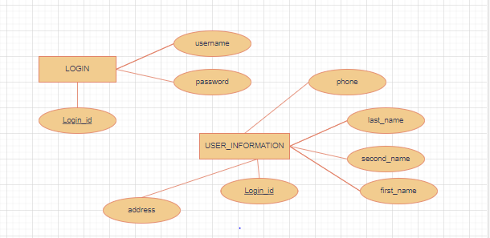

## 8. Activity flow of the system

The system's activity flow involves user registration, login, ride booking, scheduling, tracking, and reporting. Each activity will have a defined sequence of steps and interactions between the user interface and the server.

## 9. Use case to every functional requirement

Use cases will be created to illustrate the interactions between actors (users, administrators) and the system for each functional requirement. These use cases will define the steps and expected outcomes for each scenario.

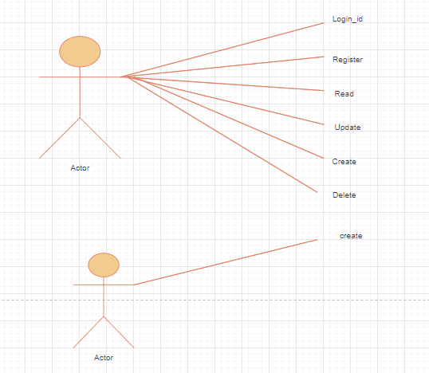

## 10. Class Diagram

A class diagram will be created to depict the relationships between various classes and entities in the system, including users, rides, bookings, and reports. It will provide a visual representation of the system's structure and behavior.

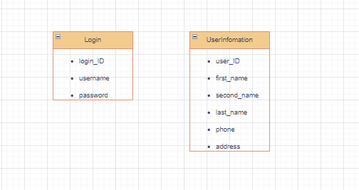

## 11. Development Technologies (languages) Front-end and Back-end

Front-end: Angular will be used for developing the web interface, and Android Studio will be used for the Android interface.  
Back-end: Spring Boot will be utilized for server-side development, and Java will be the primary programming language.

## 12. Deployment Technologies/Methods

The system will be deployed using containerization technologies like Docker. Continuous integration and continuous deployment (CI/CD) methodologies will be employed for smooth and automated deployment. The system can be hosted on cloud platforms like AWS or deployed on-premises based on the client's requirements.